**Design and Bill of Quantities:**

Abdel Wahab Turkmani, Khalil Fakih , Kareem Ramadan, Ibrahim Youssef

**System Specifications:**

As a proof of concept project, we will focus our design on differentiating between the following common household materials. The project could then be expanded to recognize more objects, but the principle of operation can be illustrated with the following recyclable materials:

* ~~Cardboard [1].~~
* ~~Tissue paper [2].~~
* ~~Transparent Polyethylene Terephthalate (PET) containers [3].~~
* ~~Opaque PET containers.~~
* ~~Glass bottles.~~
* ~~Tin cans (used to store canned goods).~~
* Paper/Cardboard/Tissue [1]
* Glass [2]
* Pastic (Opaque & Transparent) [3]
* Metal containers [4]

Additionally, we also wish to output the percent fullness of the paper wastebasket with a maximum uncertainty as low as possible (10% tentatively) to save on garbage bag wastage.

**Hardware Design:**

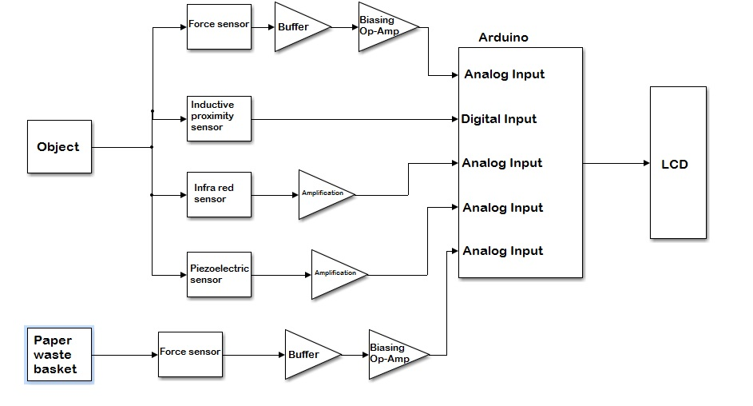We have opted to use an Arduino due to the compact nature of our design. Each object to be categorized will be dropped onto a hard ~~transparent plastic~~ platform. Beneath this platform all sensors, amplification circuitry, and the Arduino will be encased and directed at the material to be sorted.

**Software Design:**

We will use the input quantities from the various sensors to make a decision about which type of material is present. A possible decision branch our program would employ is illustrated in following pseudo code algorithm. However this remains susceptible to change based on experiments we intend to carry out to establish clear differences in the properties of the materials that we can detect with our sensors:

**if** the inductive proximity sensor returns a high voltage

**then** metal is suspected.

**else if** there is a high frequency spike, **and** a low amount of reflection detected.

**then** glass is suspected.

**else if** force sensor reads a low pressure **and** a high amount of reflection detected.

**then** cardboard is suspected.

**else if** force sensor reads a low pressure **and** a low amount of reflection detected.

**then** tissue paper is suspected.

The decision is then displayed on the LCD output.

Moreover, the program will calculate the percent fullness of the paper basket based on the average density of cardboard and tissue paper (likewise for the wastebaskets of the other materials), and the pressure of the second force sensor, and display the percentage on the LCD display.

**Note:** In order to analyze the frequency content of the incoming audio signal, we will make use of the readily available Arduino Fast Fourier Transform Library [4]. Using this library we will be able to analyze the frequency of an audio signal at key frequencies.

**Bill of Quantities:**

|  |  |  |  |
| --- | --- | --- | --- |
| Sensor | Quantity | Supplier | Total Price ($) |
| Force Sensor | 2 | Kataranji | 28 |
| Piezoelectric Transducer | 1 | Kataranji | 1.5 |
| Infrared Sensor | 1 | Kataranji | 1.5 |
| Inductive Proximity Sensor | 1 | Kataranji | Pending availability |

**References:**

[1] PET info: http://www.petresin.org/faq.asp

[2] FFT library: <http://wiki.openmusiclabs.com/wiki/ArduinoFFT>

[3] Carboard density: <http://www.engineeringtoolbox.com/density-solids-d_1265.html>

[4]Tissue paper density: http://www.paperonweb.com/density.htm